**Part 1 :**

**

**Part 2 :**

Question 1 :

From the given data op-amp open loop gain will be 10000(gmR) and UGF 10 MEGAhz

Therefore a pole at 1Khz(RC=1/omega) so we have two equations to get R,C,gm.

We no other constrains on the circuit elements so we can make an assumption for one element of the circuit, so let R=1k , from the equations gm =10, C=159.155n .

Op-amp sub Circuit Netlist:

/////There is a Typo error in one of the comments I meant Voltage Controlled Current Source not Current Controlled Voltage Source of This Pic.//////

Op-Amp Sub Circuit Bode Plot: UGF=10Megahz , DC_Gain=80db 🡪 10000

Question 2 :

Non-Inverting Amp TF analysis using 1V DC :

Gain almost 10

Question 3 :

Transient Analysis using sine wave for 2 complete cycles of the input with Amp 1v and 1khz freq , Peak Values of Vsig and Vout found using measure command.

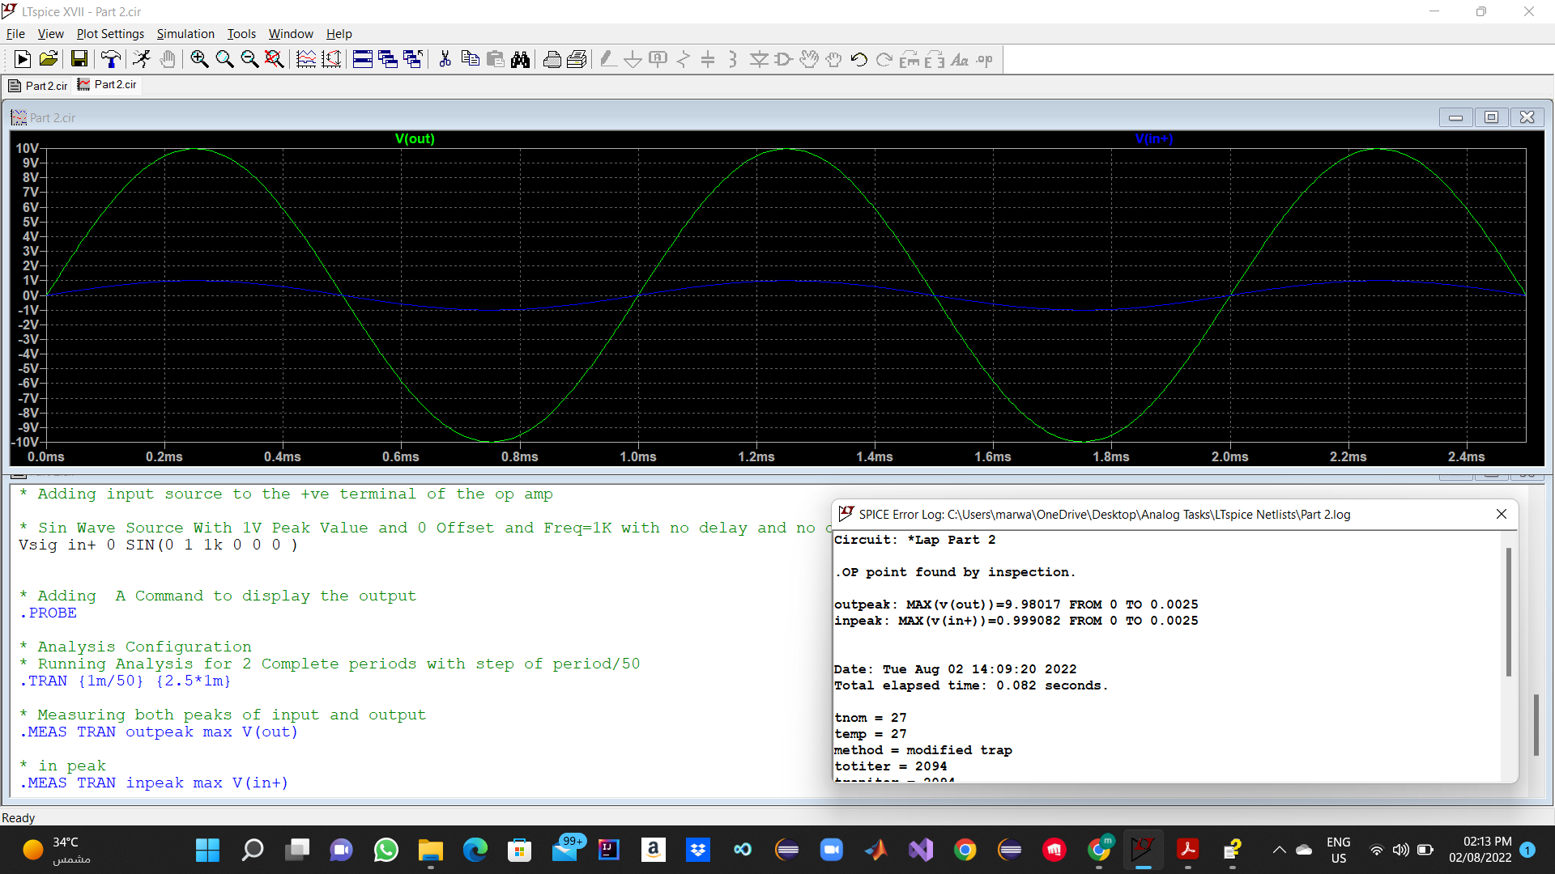

Question 4 :

The Voltage gain is 10

|  |  |  |
| --- | --- | --- |
| Hand Analysis | TF Analysis | Transient Analysis |
| A=1+(RF/R)=1+9/1=10 | A=9.99001 | A=Output Peak/ Input Peak  A=9.98017/0.999082=9.989340214 |

Hand Analysis is the ideal value of the gain , Transfer function and transient analysis is almost the same but the slight difference might be due to the solving of the differential equations at the transient analysis while solving easier model at the TF analysis.

(Both TF And Transient analysis are Accurate)

Question 5 :

The Differential Input signal is the red signal amplitude Ideally is qual to 0 as Vin+ Ideally equal to Vin- due to the Very Large Gain and the -Ve feedback stables the system, See hand analysis.

Question 6:

At 10Megahz (UGF) Gain magnitude is Equal to 1 :

Comment:

Vin+ not equal to the Vin- as in the very large gain case ,

Vin-=1/10*Vout , Simulation Results are equal to the Hand analysis results.

Question 7:

Dc Gain and Bandwidth and UGF (GBW) Calculated using measure and visible in the figure , UGF Clear In the drawing 10 Megahz @ 0db 🡪 Vin=Vout,Gain=1.

14 db Gain for the 4k Resistor.

20 db Gain for the 9k Resistor.

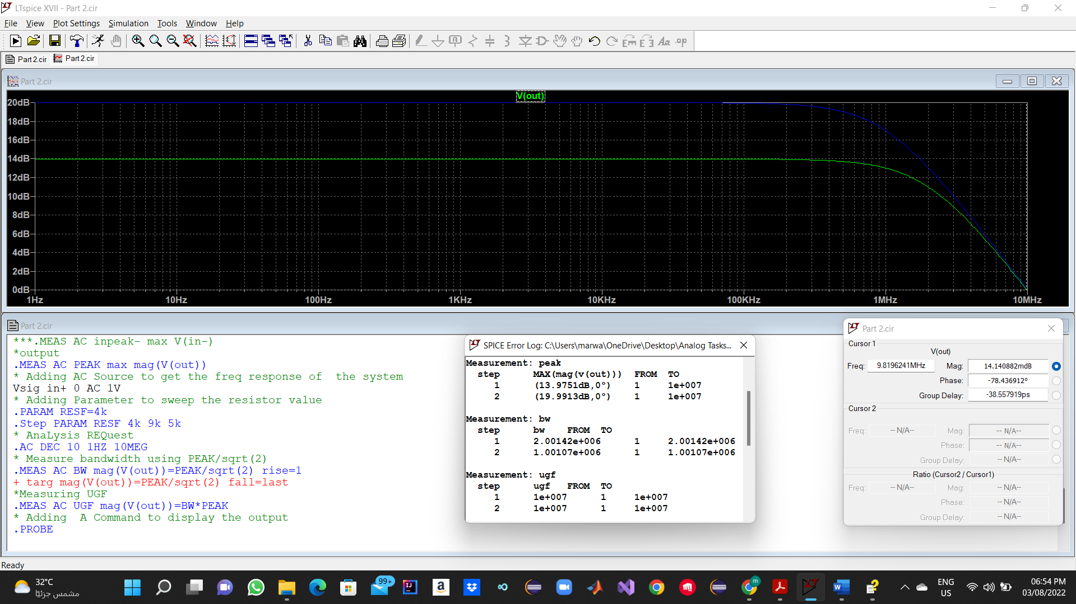

Question 8:

No there will be no clipping , The Amplifier Amplifies the signal within The Bandwidth regarding its magnitude.

Question 9:

Comment:

The Results are almost the same from Hand Analysis and Ac Analysis (Ac Analysis is very accurate ).

See Table below:

|  |  |  |
| --- | --- | --- |
| Type | Hand Analysis | AC Analysis |
| Gain | For 4K Resistor :  Gain =5 , 14db  For 9K Resistor :  Gain =10 , 20db | For 4K Resistor :  Gain =4.9975, 13.9751db  For 9K Resistor :  Gain =9.9899 , 19.9913db |
| Cut off Frequency | For 4K Resistor :  Fc =2Mhz  For 9K Resistor :  Fc = 1Mhz | For 4K Resistor :  Fc =2.00142Mhz  For 9K Resistor :  Fc = 1.00107Mhz |
| GBW(UGF) | For 4K Resistor :  GBW=10Mhz  For 9K Resistor :  GBW= 10Mhz | For 4K Resistor :  GBW=10.00209645Mhz  For 9K Resistor :  GBW= 10.00058919Mhz |